

**ARABICA VIET NAM TECHNOLOGY APPLICATION JOINT STOCK COMPANY**

**USER MANUAL**

**Voicemail content management system**

**Hà Nội, 08/2021**

**CHANGE LEADERBOARD**

*A – Create New, M – Modify, D – Delete

|  |  |  |  |  |  |  |
| --- | --- | --- | --- | --- | --- | --- |
| **Day**  **change** | **Location**  **change** | **A*, M, D** | **Origin** | **Session**  **old version** | **Description of**  **changes** | **Session**  **new version** |
| 29/08/2021 | Entire | A |  |  | Create a new document | 1.0 |

TABLE OF CONTENTS

PART 1: Introduction 4

1.1 Document purpose 4

PART 2: Voicemail content management software user manual 5

2.1 Login 5

2.2 Log out 6

2.3 Traffic report 6

2.4 Subscriber report 7

2.5 Call histories 8

2.6 Emergency Voice Message 9

2.7 Call to Short Code 10

2.8 On/Off Packages 11

2.9 SMS Histories 12

2.10 SMS Notification 13

# PART 1: Introduction

## Document purpose

**General purpose**

* This document is built for detailed manual work manipulating Voicemail management system functions
* The content presented in the document is concise, in the order of functions and instructions for the implementation step by step. So users can easily use the program through this document
* This document is provided to the User Guide for Software version 1.0

**Scope of use**

* This document applies to the Voicemail content management system
* This document serves the following audiences: System administrators and individuals using the system.

**Document description**

* Part 1: Introduction.
* Part 2: Voicemail content management software user manual.

# PART 2: Voicemail content management software user manual

## Login

Purpose: Log in to the system to use the system

Steps to log in to the system:

* Step 1: Access to provided link to the system.
* Step 2: Enter the information including: username, password and click **Login.**

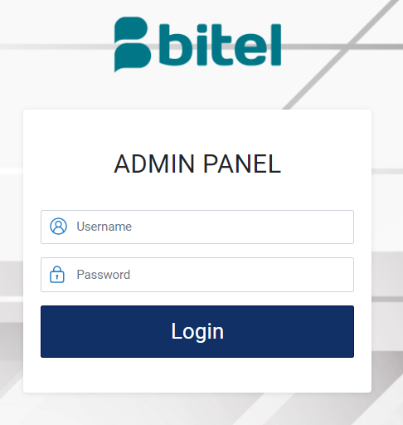

## Log out

Purpose: To enhance information security when not using the software, users should log out of the software.

* To log out of the system, the user clicks on **Logout** from sidebar. If you can’t find the menu, click on caret icon to open the menu.

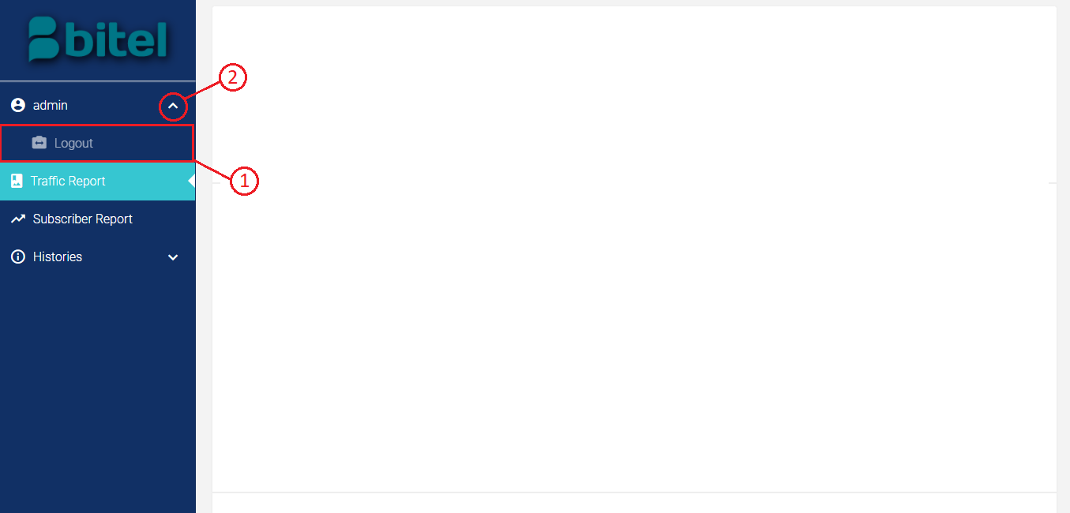

## Traffic report

Purpose: Allows user follow traffic on the system.

Steps to follow:

* Step 1: Successfully log in to the system with the provided account, click on **Traffic Report** from sidebar.

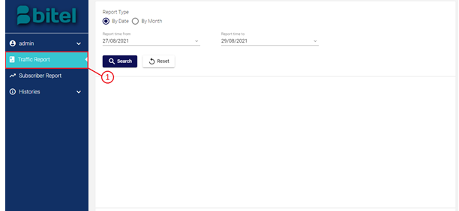

* Step 2: Select a date range , and click on **Search** button to get the report.

The system traffic will be shown as charts below.

Click on **Reset** button will set date range to original state.

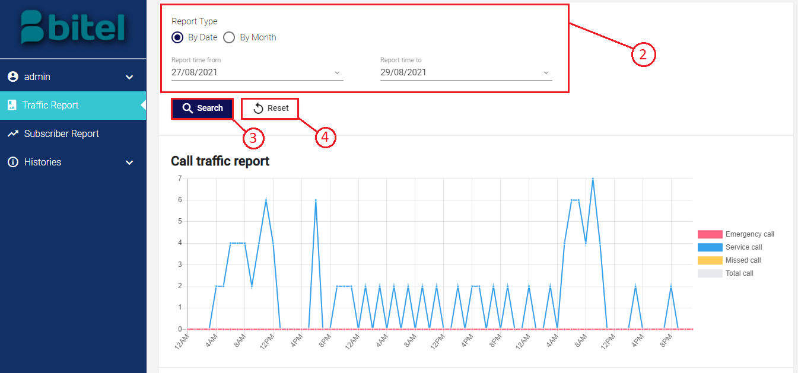

## Subscriber report

Purpose: Allows user follow subscribers on the system.

Steps to follow:

* Step 1: Successfully log in to the system with the provided account, click on **Subscriber Report** from sidebar.

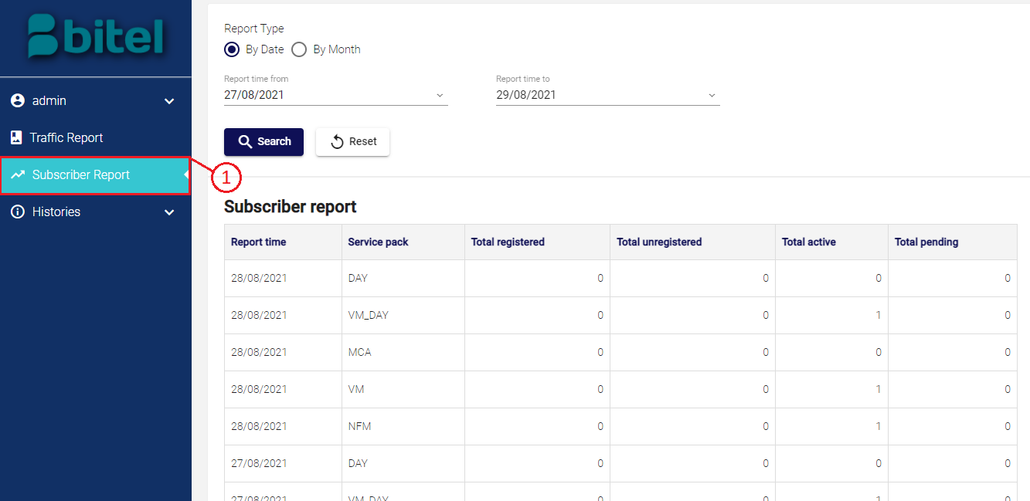

* Step 2: Select a date range , and click on **Search** button to get the report.

The reports on subscribers will be shown below.

Click on **Reset** button will set date range to original state.

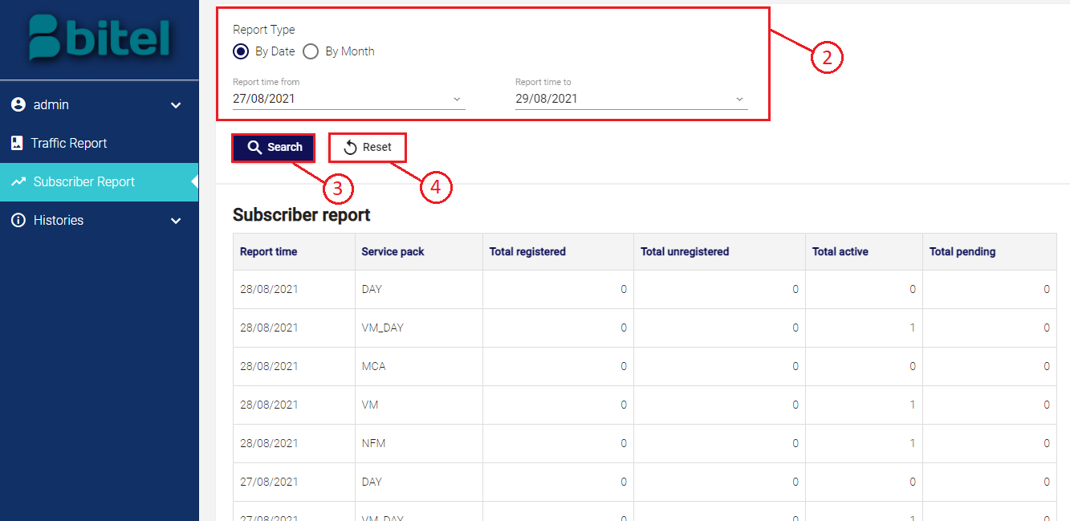

## Call histories

Purpose: Allows user follow call histories of subscribers on the system.

Steps to follow:

* Step 1: Successfully log in to the system with the provided account, open **Histories** menu from sidebar and click on **Call Histories** .

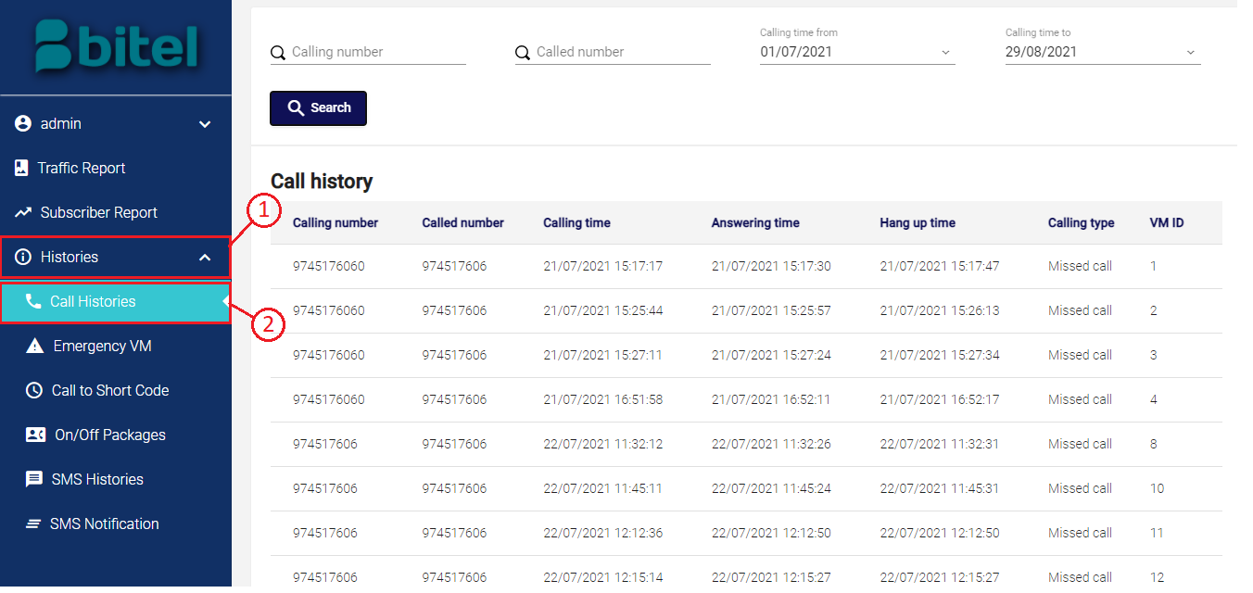

* Step 2: Input search information and date range , and click on **Search** button to get the information.

Call histories on system will be shown below.

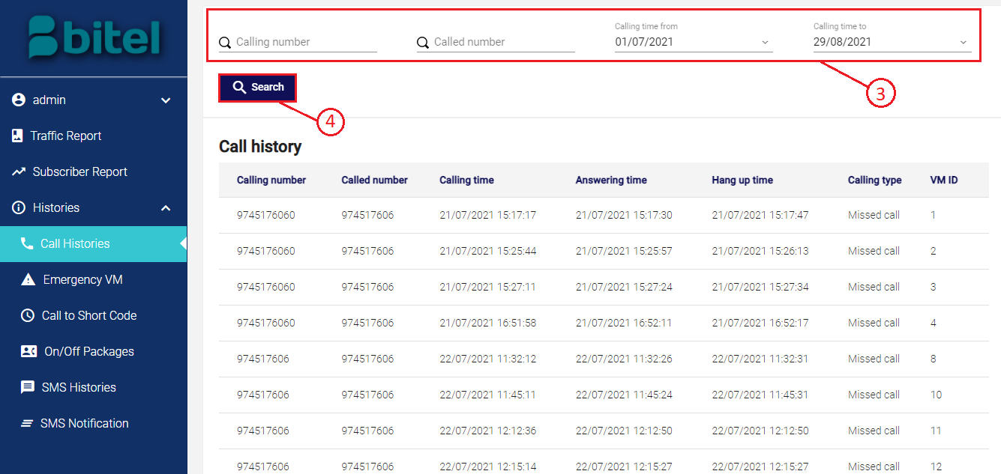

## Emergency Voice Message

Purpose: Allows user follow emergency voice mails on the system.

Steps to follow:

* Step 1: Successfully log in to the system with the provided account, open **Histories** menu from sidebar and click on **Emergency VM** .

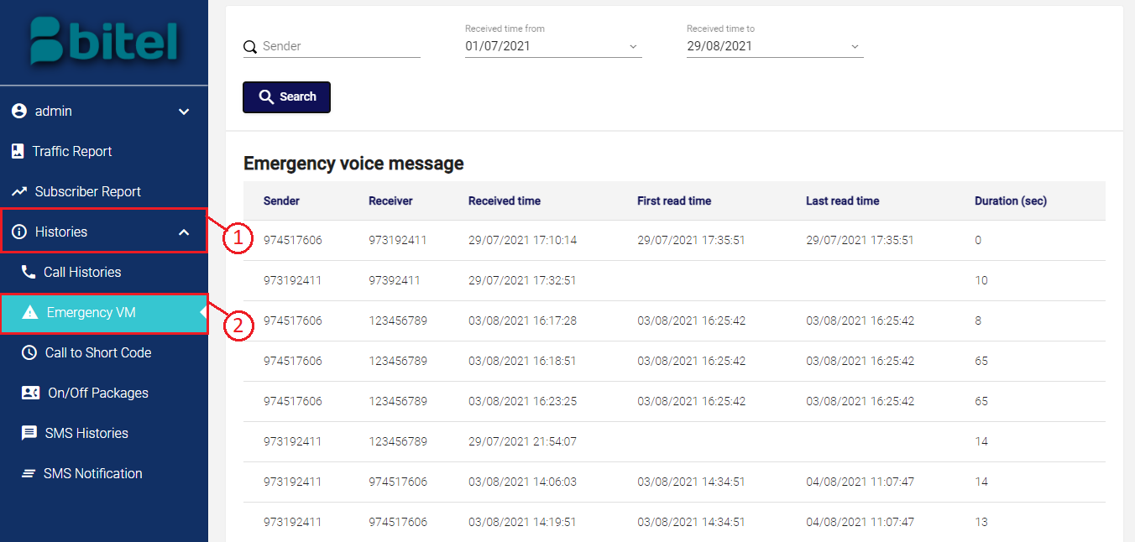

* Step 2: Input search information and date range , and click on **Search** button to get the information.

Emergency voice messages on system will be shown below.

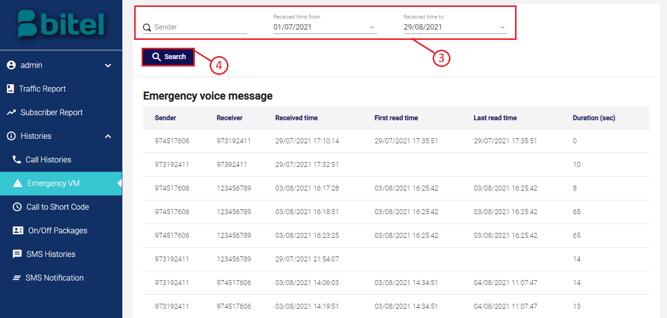

## Call to Short Code

Purpose: Allows user follow calls to short code of the system.

Steps to follow:

* Step 1: Successfully log in to the system with the provided account, open **Histories** menu from sidebar and click on **Call to Short Code**.

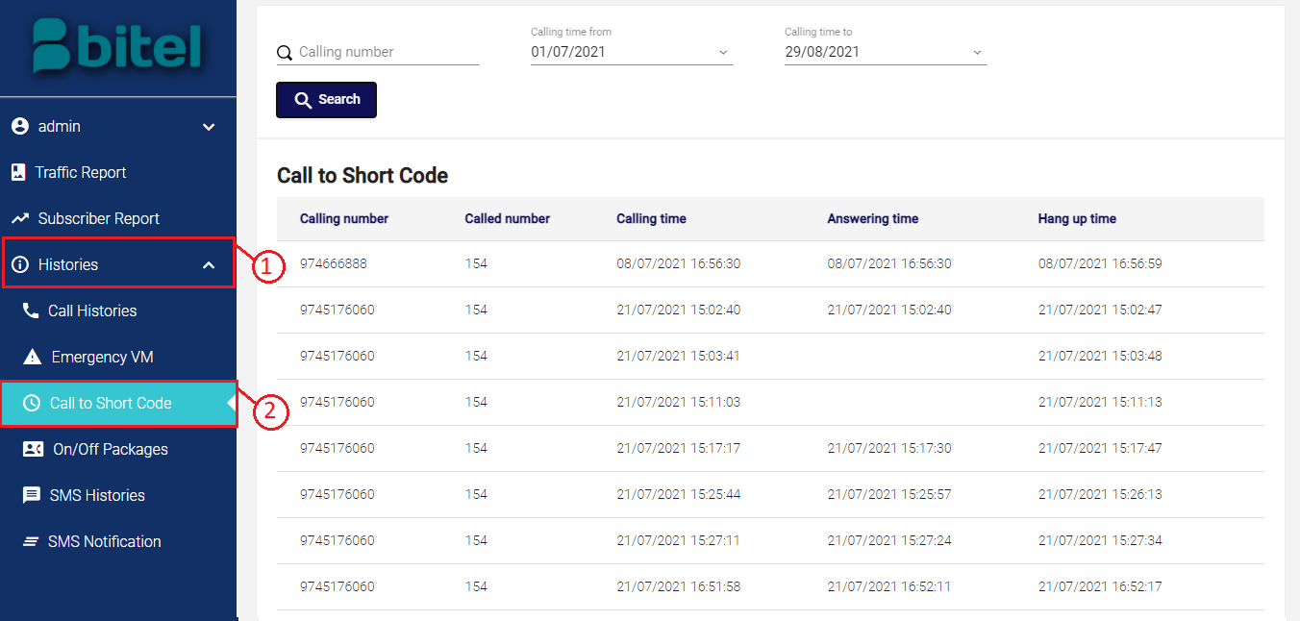

* Step 2: Input search information and date range , and click on **Search** button to get the information.

Calls to short code on system will be shown below.

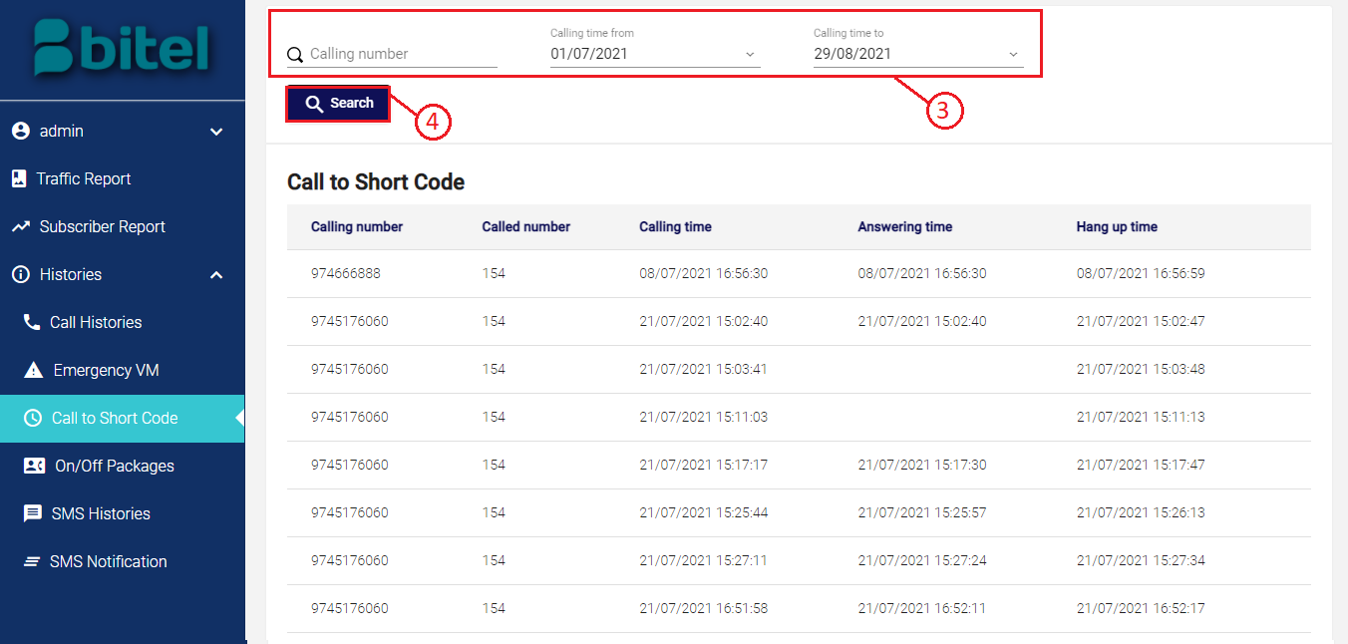

## On/Off Packages

Purpose: Allows user follow service packages of subscribers on the system.

Steps to follow:

* Step 1: Successfully log in to the system with the provided account, open **Histories** menu from sidebar and click on **On/Off Packages** .

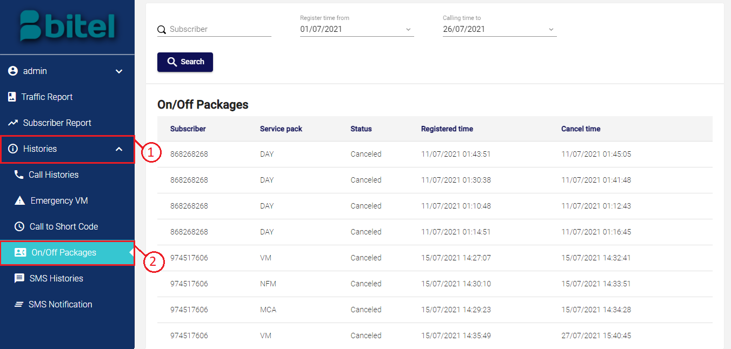

* Step 2: Input search information and date range , and click on **Search** button to get the information.

Service packages status on system will be shown below.

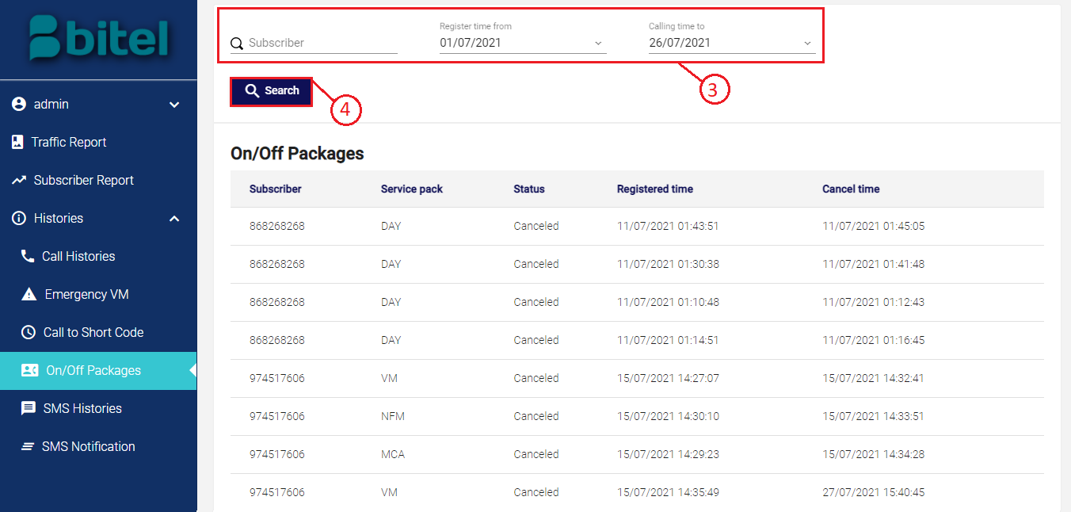

## SMS Histories

Purpose: Allows user follow SMS histories of subscribers on the system.

Steps to follow:

* Step 1: Successfully log in to the system with the provided account, open **Histories** menu from sidebar and click on **SMS Histories** .

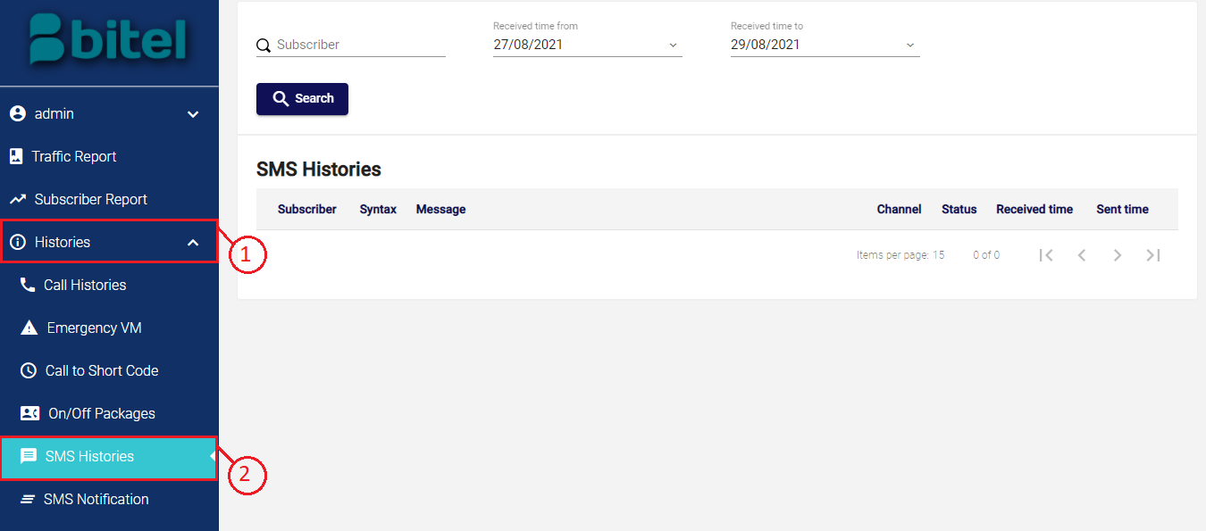

* Step 2: Input search information and date range , and click on **Search** button to get the information.

SMS histories on system will be shown below.

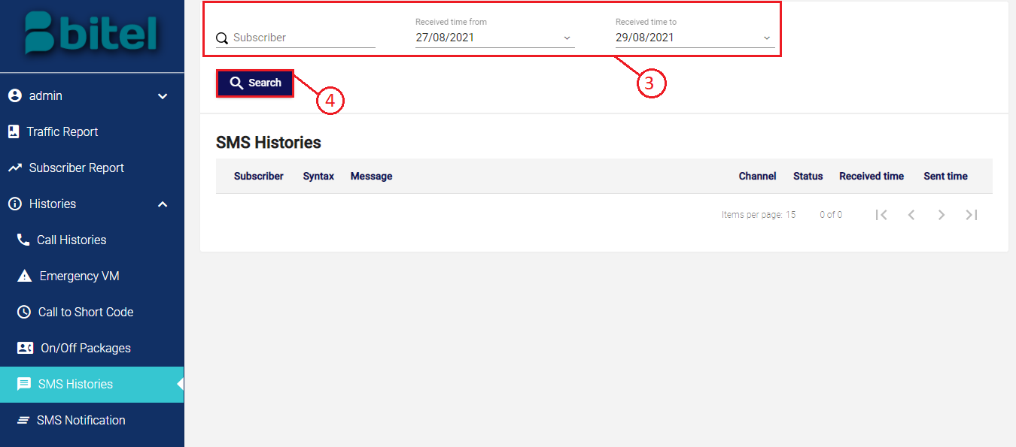

## SMS Notification

Purpose: Allows user follow SMS notifications on the system.

Steps to follow:

* Step 1: Successfully log in to the system with the provided account, open **Histories** menu from sidebar and click on **SMS Notification** .

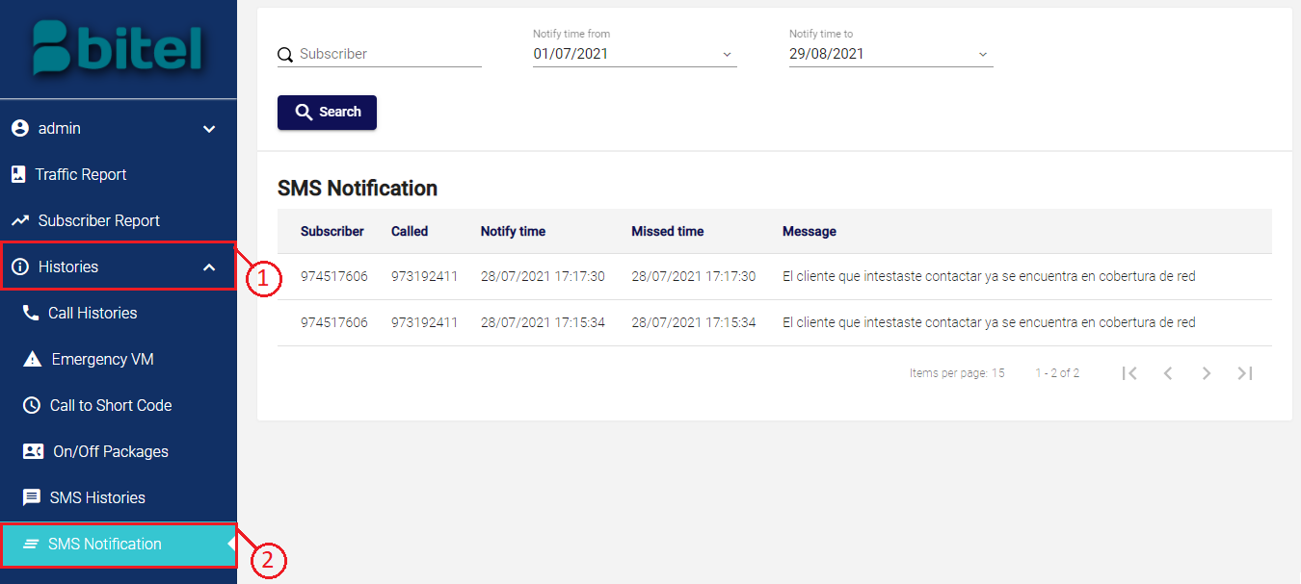

* Step 2: Input search information and date range , and click on **Search** button to get the information.

SMS notifications on system will be shown below.

